

ACCIDENT / INCIDENT INVESTIGATION REPORT

EIS Waste Services Ltd
Location: Champion X, Aberdeen
Date of Incident: 29th September 2025
Reported by: Dave McKenzie
Date of Report: 3/10/2025
Investigator: Raymond Henderson – Transport Director
Department: Transport

1. Summary of Incident
On Monday, 29th September 2025, an incident occurred at Champion X, Aberdeen involving an EIS Waste Services vehicle.
During a scheduled waste collection, the vehicle rolled forward after the driver exited the cab, resulting in minor damage to a site gate. No injuries occurred.
Following an investigation, it has been determined that the incident was caused by human error related to the handbrake not engaging correctly as the driver exited the cab.

2. Sequence of Events
- The driver arrived on site at Champion X to carry out a scheduled waste collection.
- Upon completing the manoeuvre and stopping the vehicle, the driver attempted to apply the handbrake.
- The driver pulled the handbrake button but simultaneously began to exit the cab.
- The handbrake failed to engage fully, resulting in the vehicle beginning to roll forward slowly.
- The driver immediately re-entered the cab and applied the brake correctly, bringing the vehicle to a stop.
- During this short movement, the vehicle came into contact with a site gate, causing minor damage.
- No personal injury occurred, although the vehicle sustained a crack on the windscreen.

3. Immediate Actions Taken
- The driver immediately reported the incident to his line manager.
- The site area was made safe, and the vehicle was removed from the area.
- A joint inspection was carried out with Dave McKenzie (Facilities Manager, Champion X) and EIS Waste Services Maintenance team.
- It was agreed that EIS Waste Services Ltd would arrange for repairs to the gate.
- The gate was repaired by EIS-appointed fabricators on 8th October 2025:
  - Gate removed at 07:30 am.
  - Repairs completed and gate reinstated early afternoon.

4. Root Cause Analysis
Primary Cause:
- Human Error: The handbrake was not fully engaged before the driver exited the vehicle.
Contributory Factors:
- Operator action – premature exit from cab before ensuring vehicle was secure.
- Possible over-familiarity with routine tasks leading to a lapse in concentration.
- No mechanical defect identified with the vehicle.

5. Findings from Driver Interview
During the post-incident interview, the driver confirmed the following:
- He believed he had applied the handbrake correctly at the time.
- He began to step out of the cab immediately after pulling the handbrake button.
- Upon realising the vehicle had moved, he immediately re-entered and stopped it.
- The driver acknowledged the mistake and accepted full responsibility.
The investigation found the driver was cooperative, remorseful, and understood the seriousness of the lapse.

6. Corrective & Preventive Actions
Action | Responsible Person | Completion Date | Status
Driver to receive refresher training on vehicle parking and securing procedures | Transport Manager | 30/9/2025 | Completed
Review of handbrake engagement procedure during driver assessments | Transport Manager | 30/9/2025 | Completed
Site repairs coordinated with Champion X | Operations Manager | 8th Oct 2025 | Completed

7. Outcome / Damage Summary
- Damage: Minor impact to Champion X gate frame (cosmetic and structural).
- Repairs: Gate removed and reinstalled by EIS fabricators on 8th October 2025.
- Injury: None.
- Vehicle Damage: Cracked Windscreen.
- Downtime: Minimal.
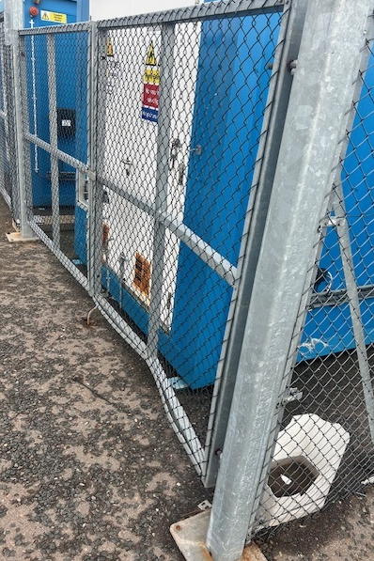

8. Lessons Learned
- Always ensure the vehicle is fully secured before exiting the cab.
- Drivers must visually confirm handbrake engagement and test the hold before leaving the seat.
- Regular refresher training and toolbox talks to reinforce safety-critical behaviour are essential.
- Continuous communication between site management and EIS ensures quick and professional resolution of incidents.

9. Conclusion
The investigation concludes that this incident was caused by human error and not mechanical failure.
The quick actions of the driver and management team prevented any escalation and ensured prompt resolution with the client.
EIS Waste Services Ltd has taken immediate steps to reinforce safe parking procedures and prevent recurrence. The company also appreciates the cooperation and understanding shown by Champion X during the investigation and repair process.

Report Completed by: 
Name: Raymond Henderson
Position: Transport Director
Date: 9/10/2025

